PHYSICS IA

**Topic: Hooke’s Law**

**Question: Does Hooke’s’ Law apply to rubber bands?**

**Dependent Variable**: The force on the rubber band

**Independent Variable:** The extension of the rubber band

**Introduction:**

This is an experiment to see if rubber bands follow the principles of Hooke’s law. Hooke’s Law is concept that was proposed by physicist Robert Hooke that states that for relatively small deformations in an object the length of its extension is proportionate to the deforming force. This experiment is commonly proven with common springs. A force mass is attached to the spring and extends the spring in a manner that is proportional to its mass. The equation to prove the effect of Hooke’s law is:

Where *F* represents the force exerted on the object, *k* is a constant value and *x* is the displacement.

This experiment is going to inquire as to whether rubber bands act like springs and when the elastic limit of the bands are reached. Rubber bands are an essential part of everyday casual life for people across all age brackets. Rubber bands have strange molecules in comparison to other materials; their particles are in long chains called polymers, when heated rubber bands tend to contrast less then when they are in a cold environment this is due to the behavior or the polymer of chains. In my experiment heat will not be a factor that is being investigated however maintaining adequate room temperature is necessary to get accurate results. I am particularly interested in this concept because I am curious to the functionality of rubber bands as they are commonly used for multi functional purposes.

**Hypothesis**

The rubber band tested will not follow the principles of Hooke’s Law because the rubber bands will not constantly expand because of the behavior of the long polymer chains. As the force on the rubber band increases so does the expansion on the rubber band. As a result of this hypothesis the graph of the force/ extension would look similar to this:

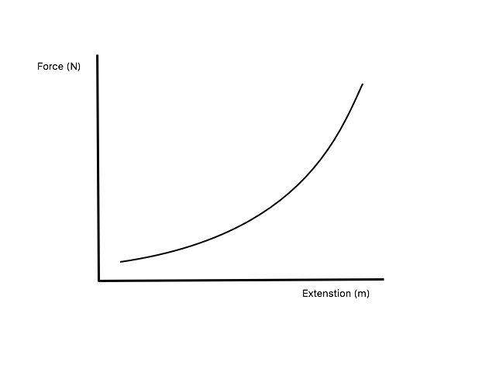

The graph of my hypothesis

**Materials:**

* A force meter
* Rubber bands 0.75 cm thick and 5.5 cm diameter
* Laptop
* Logger lite software



A visual representation of my set up

* Ruler
* Pen

**Procedure:**

My set up used a pen at the end of a desk with a 30 cm ruler below; I attached the rubber band to the pen and attached the other side of the rubber band to the force meter.

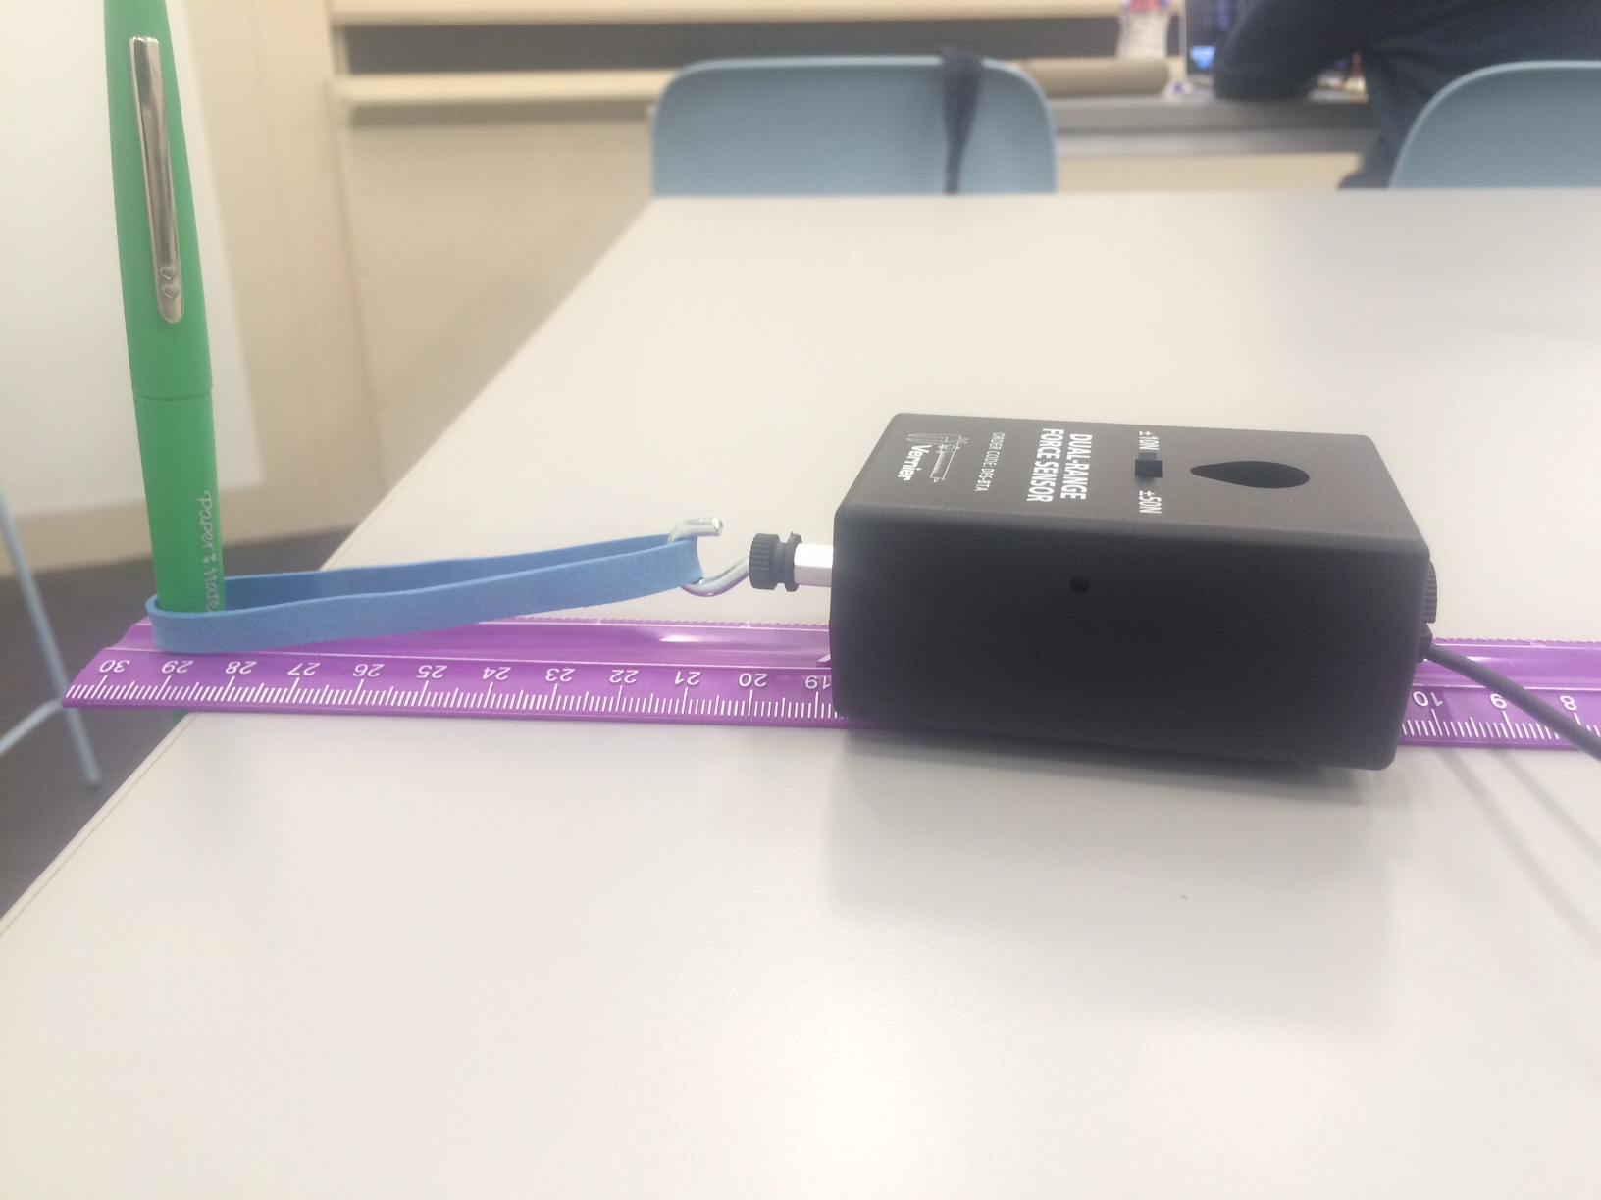

1. I marked the part of the ruler where the rubber band and the pen start on the ruler calibration in order to make accurate calculation.
2. To reduce systematic uncertainty I take note of the default force value on the force meter (0.23 Newton)
3. I extend the force meter to the nearest centimeter on the ruler and document the value shown on the force meter in Newton’s.
4. I continue to do this until I reach the end of the ruler with 12 values recorded.
5. I repeat the experiment once again to reduce random error.
6. I calculated the average of the values obtained

**Raw Data**

|  |  |  |  |
| --- | --- | --- | --- |
| **Extension (m)**  ( | **Force (N)** | | **Average (N)** |
|  | |
| 0.035 | 4.51 | 4.28 | 4.40 |
| 0.045 | 5.23 | 5.00 | 5.12 |
| 0.055 | 5.72 | 5.49 | 5.61 |
| 0.065 | 6.38 | 6.15 | 6.27 |
| 0.075 | 7.12 | 6.89 | 7.01 |
| 0.085 | 7.60 | 7.37 | 7.49 |
| 0.095 | 7.81 | 7.58 | 7.70 |
| 0.105 | 8.40 | 8.17 | 8.29 |
| 0.115 | 9.14 | 8.91 | 9.03 |
| 0.125 | 9.74 | 9.51 | 9.63 |
| 0.135 | 10.60 | 10.37 | 10.49 |
| 0.145 | 10.82 | 10.59 | 10.71 |
| 0.155 | 11.74 | 11.51 | 11.63 |
| 0.165 | 12.59 | 12.36 | 12.48 |
| 0.175 | 13.73 | 13.50 | 13.62 |
| 0.185 | 14.54 | 14.31 | 14.43 |
| 0.195 | 15.33 | 15.10 | 15.22 |
| 0.205 | 15.40 | 15.17 | 15.29 |
| 0.215 | 16.82 | 16.59 | 16.71 |

**Processed Data**

Plotting the value of the extension against the value average force exerted on the rubber band the following graph was obtained:

In the equation:

66.575 is the calculated gradient which should be equivalent to *k* as the constant in the equation.

*k*= 66.575 N/m

R in the graph indicates the degree of linearity of the graph with 1 being the most linear degree. The degree of the graph above is 0.98934 meaning it is highly linear.

**Evaluation of Data**

The rubber band tested in this procedure follows the principles of Hooke’s Law which states that for relatively small deformations in an object the length of its extension is proportionate to the deforming force because it is almost perfectly linear. This result does not coincide with my hypothesis, however this may be as a result of the type of rubber band used in the procedure. There are various factors that can affect the elasticity of a rubber band

1. Diameter: According to the ME72 Engineering Design Laboratory in Caltech the elasticity constant of a rubber band (*k*) with a diameter of 8 centimeters is 88 *N/m*. In reference to my experiment the rubber band has a diameter of 5.5 centimeters and an elasticity of 66.575 *N/m*. This shows how the diameter of a rubber band can affect its elasticity; furthermore it proves that the diameter of a rubber band is proportional to its elasticity, although the thickness of the rubber band in the Caltech lab was not specified.
2. Thickness: The rubber band used in the experiment is 0.75cm thick, which affects its elastic properties, giving it similar elastic support to a spring. Using a thick rubber band increases the value of *k* because a thick rubber band is similar to two parallel rubber bands receiving the same force. For each ,to stretch the combined sytem by a cerain extension (*x*) you will have to apply the same *F* (force) to each of the rubber bands doubling the force needed . Hence for a combined system the equation will be as following:

The thickness of the rubber band explains its ordinance to Hooke’s law. The graph will continue to be linear until the rubber band reaches its elastic limit however reaching the elastic limit of a rubber band is synonymous with the rubber band cutting, at that point it is almost impossible to make accurate calculations.

The method in which I carried out the experiment may have also been a reason for the results that I reached. Instead of making the force a dependent value in the experiment I chose the extension to be the dependent value and the force as the independent value, this brings an interesting twist into the process of determining whether the extension is linear. The uncertainty of the computer generated constant (*k*) to my calculated constant may have been caused by systematic or random error however the uncertainty is relatively little because the R value of 0.98934 is almost equivalent to 1.

**Conclusion**

According to my experiment rubber bands do follow the principles of Hooke’s Law however this has certain implications when it comes to the utilization of rubber bands from the industrial process to the simple household usage. A way to further develop this hypothesis is to show what effects the shape of the rubber band has on its elastic properties. It would be interesting to see how the seemingly simple rubber band can be revolutionized to something more complicated for much more profound use to society.

* **Limitations to my experiment**

1. I may have come up with more interesting hypothesis if I varied the type of rubber band used in the experiment
2. Switching the dependent and independent variables from the traditional Hooke’s law experiment procedure could have affected my results.

**Bibliography**

* Caltech ME72 Engineering Design Laboratory and Contest #32 Elastic Band Specifications. (n.d.). Retrieved February 18, 2016, from http://design.caltech.edu/Archive/2001/handouts/elasticband32.html
* Elasticity. (n.d.). Retrieved February 17, 2017, from <http://hyperphysics.phy-astr.gsu.edu/hbase/permot2.htm>
* Examples of Uncertainty calculations. (2003, July 17). Retrieved February 17, 2016, from <http://spiff.rit.edu/classes/phys273/uncert/uncert.html>
* Finio, B. (2015, April 09). Stretch It! How Does Temperature Affect a Rubber Band? Retrieved February 18, 2016, from http://www.scientificamerican.com/article/stretch-it-how-does-temperature-affect-a-rubber-band/
* Rubber bands and Hooke's law. (2014, April 16). Retrieved February 18, 2016, from http://physics.stackexchange.com/questions/108653/rubber-bands-and-hookes-law
* T. (2014, November 9). Hooke's law | physics. Retrieved February 17, 2016, from http://www.britannica.com/science/Hookes-law